Author instructions
N. FirstAuthor ¹, M. SecondAuthor ², A.ThirdAuthor ³
¹ Affiliation and email of first author,
² Affiliation and email of second author,
³ Affiliation and email of third author,

Keywords: Please include 3-4 Keywords.

Introduction
Abstracts for the 2nd CEACM MSF 2026 CONFERENCE should be prepared in the form of mini papers with at least 2 pages. The abstracts should be created using Word’s DOC or LaTeX templates available at conference website (https://ceacm2026.com/). Submitted abstracts (having two or more pages) will be included in a Book of Abstracts with an ISBN number.
Formatting recommendations:
* Calibri font should be used in the text of the abstract.
* All formatting styles are embedded in the document. They are: Title, AuthorName, Affiliation, Section and Normal text and Acknowledgments. We suggest to use those styles instead of selecting properties manually. The simplest way is to replace the text, figures and equations in this template with your own content.

Paper size and margins
Use the standard A4 (210 × 297 mm) paper size. Allow 2 cm left, right, and bottom margins and a 3 cm top margin. Do not leave any additional space above the title. The title should be followed by authors’ names (bold-italic) and respective affiliations (italic). Page numbers, headers, and footers must not be typed.

Equations
Equation is placed in single row, three columns table with invisible frames. To place the equation copy table below and update the equation in the second column and number manually.
 | $$γ=\frac{1}{\sqrt{1-\frac{v^{2}}{c^{2}}}}$$ | (1)
In two-page documents like an abstract, use automatic equation enumeration is not recommended.

Figures and tables
To place figure insert image in the center of page and describe according presented example. Similarly to the equations placement rules, manual enumeration is recommended. Calibri 10pt is used to make figure description. The same rules are applied for tables placement.
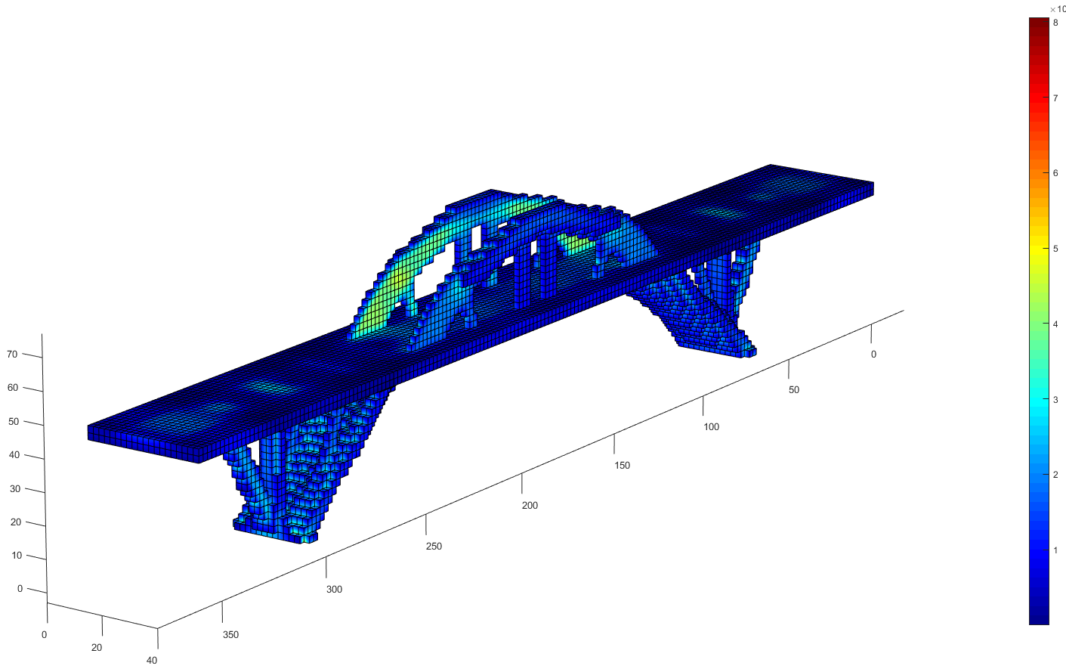
Figure 1. Description of the figure.

Acknowledgements
The authors acknowledge the financial support of the Funding Body.

References
Any references should be placed at the end of the paper and referenced in the paper through the number in square brackets. The format of a sample book [1] and journal [2] reference is given below.
[1] Author’s initials. Author’s Surname, Book Title, edition (if not first). Place of publication: Publisher, Year.
[2] Author’s initials. Author’s Surname. (Year, Month). Title of article. Journal Title [type of medium]. volume number, issue number, page numbers if given. Available: URL

